|  |  |
| --- | --- |
| Module name | Web programming using PHP |
| Assignment title | TMA |
| Student Name | Manea Valentin Cornel |
| Student ID number | xxxxxx |
| Tutor Name | Ian Hollender |
| Assignment due data | 25/11/2020 |

Web Programming using PHP

TMA

TMA

# Strategy

As an overall approach, the system functionality was divided into a set of individual functions. Each individual function working on a set of data, in order to produce a result.

The starting point of the system is focused on parsing and storing raw data from a set of text files found within a directory. As soon as the data is stored, the validation process starts, which is used to identify faulty inputs. In order to obtain the necessary result, several computations are performed over the validated data.

The last part of the program is focused on formatting and displaying data.

# Design

It is very important to specify that the pseudo code is used just as a narrow reference and hides code complexity. A sequence diagram was drawn based on the pseudo methods, offering a brief understanding between system components interaction in a time scale.

The sequence diagram makes the order of the steps which need to be followed very clear.





Sequence diagram based on the previous pseudo methods.

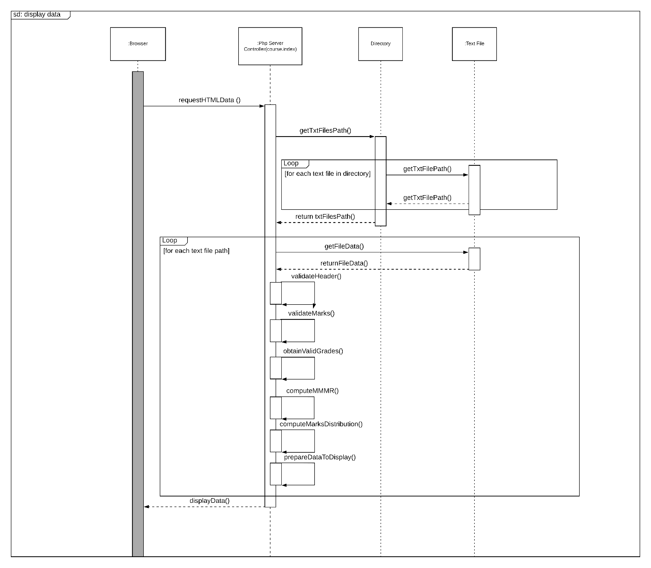

Figure Display data